--------when you write query within query then it is nested query

----outer query is called as parent query and inner query is called as child query

----output of child query is used as input to outer query

-------if child query is independent query then it is called as nested query and it gets executed only once.

------ if child query is dependent on outer query then it is called as co-related query. and child query will get executed once for each row in the outer query

-nested query joins

use nested query if you need data only from one table in the output

use joins if you need data from multiple table. avoid joins as much as possible because it is time consuming.

--------maximum level of nesting is 255

--------find all employees with sal = either blake salary or smith salary

select empno,ename,sal

from emp

where sal in (select sal

from emp

where ename in (‘BLAKE’,’SMITH’))

------- select all employees with sal > all salaries of avg salary of dept 10 and 20

select empno,ename,sal

from emp

where sal> all (

select avg(sal)

from emp

where deptno in (10,20)

group by deptno

)

---------select all employees with sal > avg sal of deptno 10 and < max sal of deptno 20

select empno,ename,sal

from emp

where sal between (select avg(sal) from emp where deptno=10) and (select max(sal) from emp where deptno=20)

------------nested queries in DML statement

update martin’s sal with blake’s sal

update, delete, insert

update emp

set sal=(select sal

from (select sal from emp where ename=’BLAKE’) s

)

where ename=’Martin’

--------- change salary of all employees who working in ALLEN's department to the salary of Miller.

update emp

set sal=(select sal from (select sal from emp where ename=’Miller’) s)

where deptno = (

select deptno

from (select deptno from emp where

where ename=’ALLEN’) d

)

-------- delete all employees who are working in blake’s dept and If sal > 3000

delete

from emp

where deptno=(select deptno from (select deptno from emp where ename=’BLAKE’) d) and sal> 3000

--------delete all employees who are working in Allen’s dept and sal > avg(sal of deptno 10)

delete from emp

where deptno=(select deptno from (select deptno from emp where ename=’ALLEN’) d) and

sal > (select avg(sal) from (select sal from emp where deptno=10) a)

--------- find all employees with sal > min(sal) of its own dept

corelated queries

select empno,ename,sal,deptno

from emp e

where sal> (select min(sal) from emp d where d.deptno=e.deptno)

order by deptno;

-------find all employees with sal > avg sal of all employee who work under his manager

select empno,ename,sal,mgr

from emp e

where sal > (select avg(sal) from emp a where a.mgr=e.mgr);

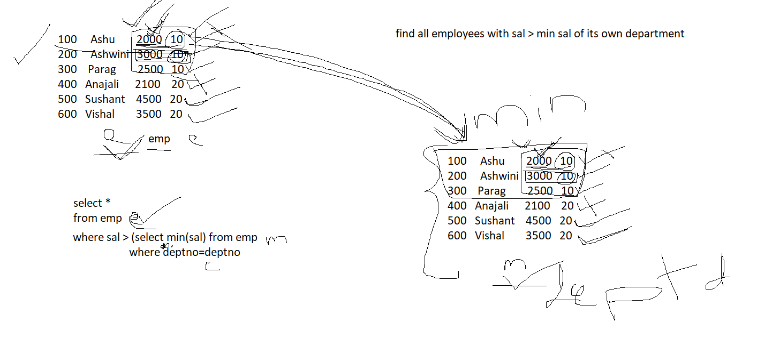

-------exists , not exists

exists -------- it return true if child query returns one or more rows otherwise returns false

not exists ------------- it returns true if child query do not return any rows otherwise returns false

----display all departments in which no employess are there

select deptno,dname

from dept d

where not exists(select \*

from emp e

where e.deptno=d.deptno)

-------- display department in which employees are there

select deptno,dname

from dept d

where exists(select \*

from emp e

where e.deptno=d.deptno)

-----display all employees who are not working as managers

select \*

from emp e

where not exists (select \*

from emp m

where m.mgr=e.empno)

------faculty(fid,fname,skills)

10 rohit java

20 sarika python

30 Narendra database

40 Tejashree security

-------room(rid,rname,loc)

100 lotus 1st floor

200 jasmin 1st floor

300 Mogra 2nd floor

400 Rose 1 st floor

--------course(cid,cname,rid,fid)

1 eDAC 100 10

2 eDBDA 200 30

3 eDTISS

4 eDAI

-------find all faculties who are not assigned to any course

select \*

from faculty f

where not exists(select \*

from course c

where c.fid=f.fid) and skills=’python’

-------find all vacant room

select \*

from room r

where not exists (select \*

from course c

where c.rid=r.rid)

---------find all departments in which no employees are there, and department location is pune

select \*

from dept d

where not exists (select \* from emp e

where e.deptno=d.deptno) and loc=’pune’;